**STAT 43000/STAT 53001 Applied Statistics Spring 2023**

**Lab 1**

**Q.N. 1)** Several studies have found that there is a relationship between the age of an individual and the time spend on internet for online shopping. Below is the data showing the age of the respondents and their answer to the question “How many minutes do you browse online retailers per week?”

|  |  |
| --- | --- |
| Age | Minutes |
| 22 | 492 |
| 50 | 186 |
| 44 | 180 |
| 32 | 384 |
| 55 | 120 |
| 60 | 120 |
| 38 | 276 |
| 22 | 480 |
| 21 | 510 |
| 45 | 252 |
| 52 | 126 |
| 33 | 360 |
| 19 | 570 |
| 17 | 588 |
| 21 | 498 |

1. Make a scatterplot to display the data.

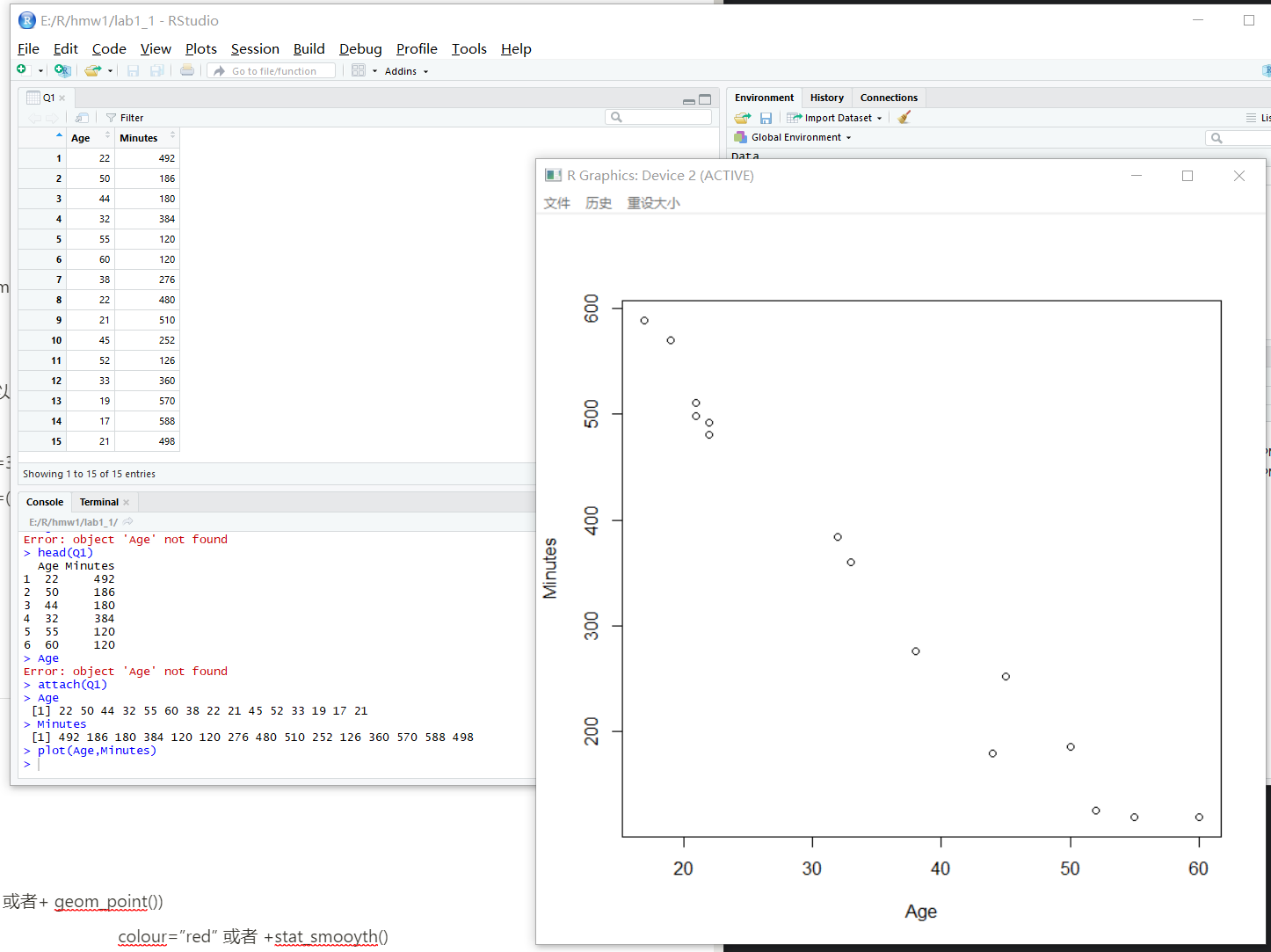

1. Find the equation of the regression line. What does the slope parameter indicate?

#Time(Minutes)=750-11.5*Age

Coefficients:

(Intercept) Age

750.0 -11.5

1. Construct a 90% confidence interval for the model parameters.
2. 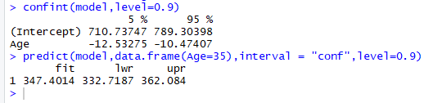

**Q.N. 2)** A marketing researcher studied annual sales of a product that had been introduced 10 years ago. The data are as follows, where x is the year coded and y is the sales in thousands of units:

x: 0 1 2 3 4 5 6 7 8 9

y: 98 135 162 178 221 232 283 300 374 395

1. Prepare a scatter plot of the data

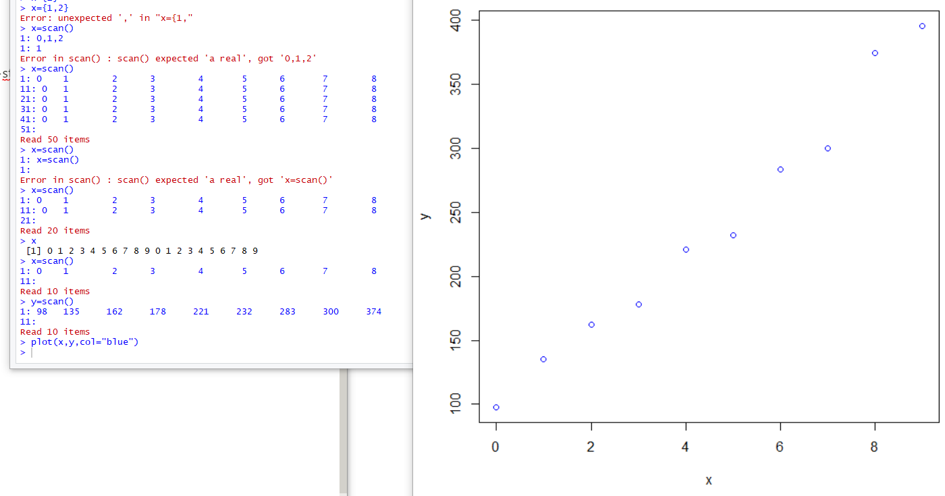

1. State the estimated regression line for the data and add it to the scatter plot.

Coefficients:

(Intercept) x

91.56 32.50

Y=32.5*x+91.56

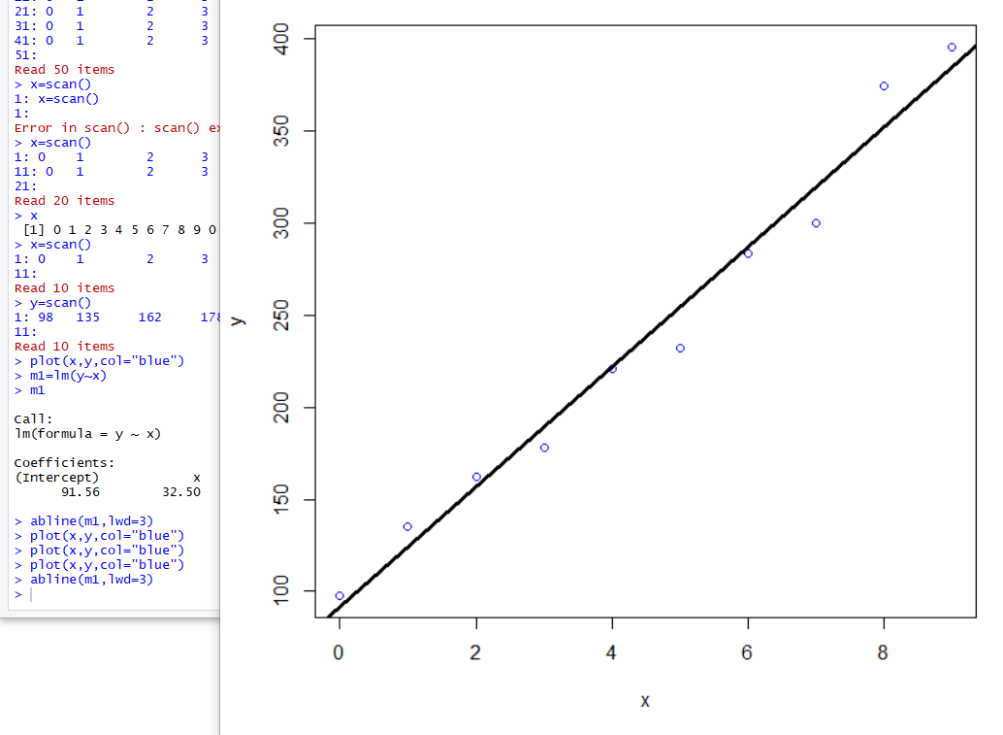

1. Use the model to predict the sales in the 10th year (i.e. For x=10). Also provide the 95% confidence interval for the predicted value.

